**CSC8502-Advanced Graphics for Games**

Rajbol Rai (190299721)

## Screenshot 1

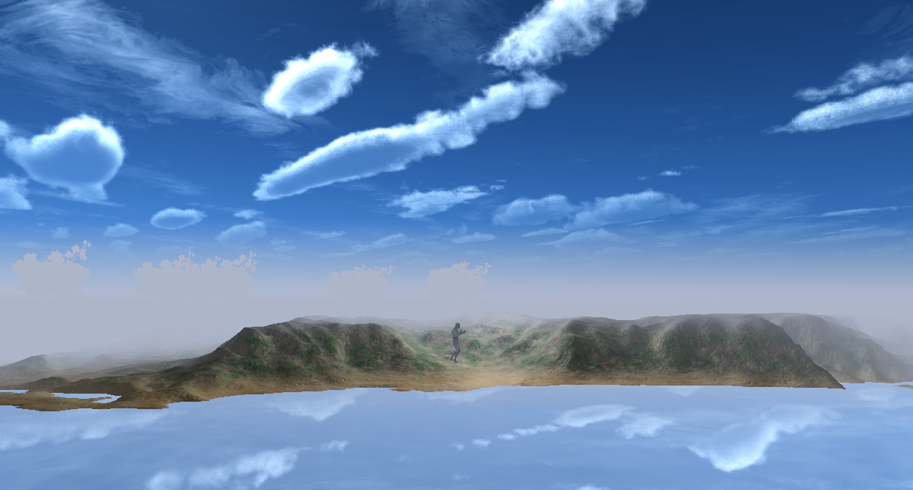

The first screenshot shows the landscape and ocean. The fog shader is active in the scene; depending on how far the triangle is away from the camera position, the output colour is mixed with the fog colour. Cubemap is active and reflected by the reflective shader active on the water quad. Finally, a point light lights the scene in the middle of the terrain.

## Screenshot 2

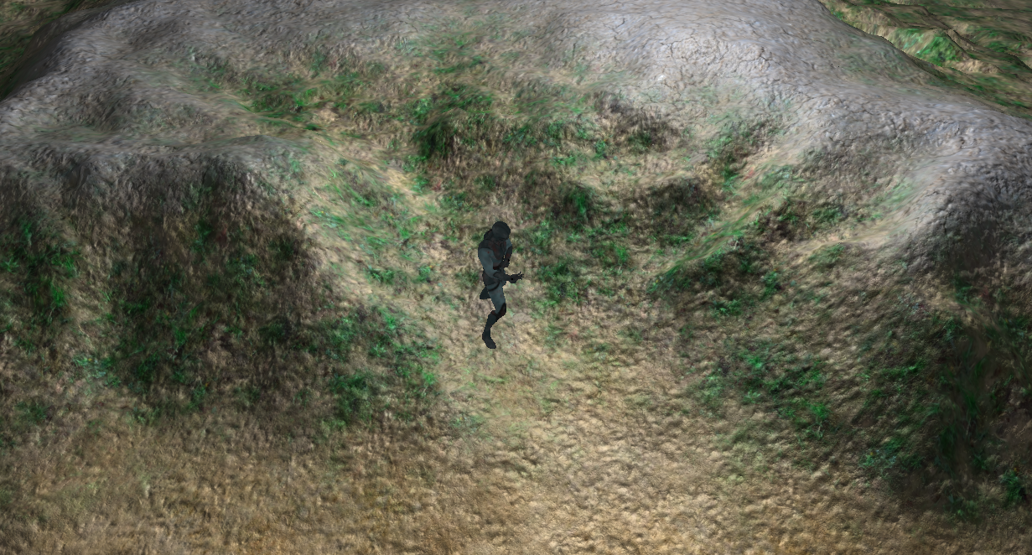

The second screenshot shows an animated object and the terrain. The terrain is textured with three different textures and uses a bump map for better lighting. The height of the vertex is used to decide which texture to use. The character uses a skeletal animation.

## Screenshot 3

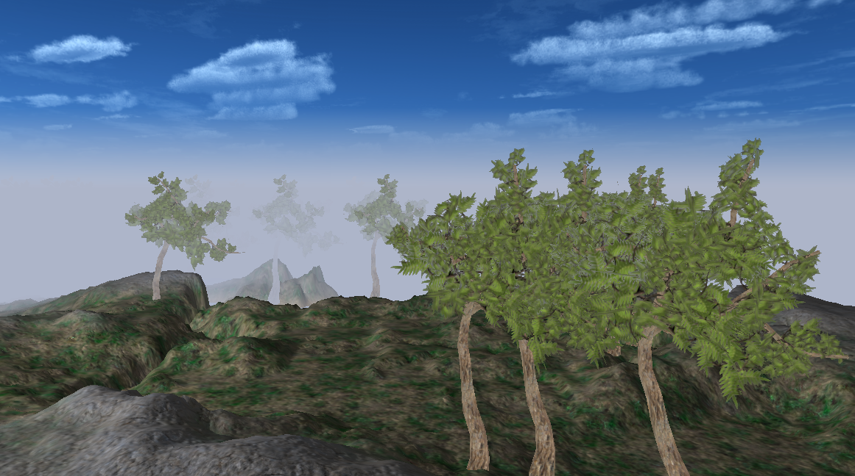

The screenshot shows additional scene elements in the form of trees working with the fog shader.

## Screenshot 4

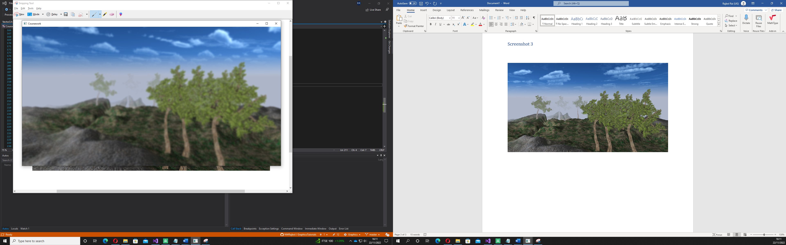

The screenshot is in the exact location showcasing the same scene elements; however, this time, with the post-processing effect, gaussian blur is enabled.

Screenshot 5

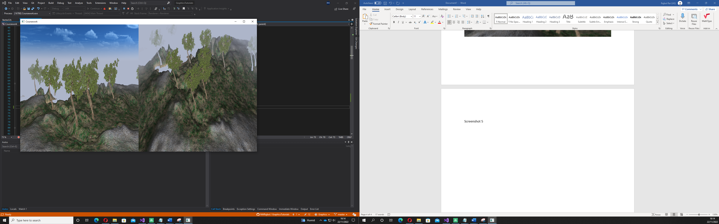

The screenshot shows two different viewpoints being rendered and displayed side by side on the window. The left camera is static while the left can still be controlled by the user’s mouse and keyboard.

# Keyboard actions

**T:** Enables blur post processing effects.

**U:** Enables split screen effect.

**V:** Stops automatic camera moving and gives camera movement to the mouse.

**B:** Activate automatic camera movement**.**